**Data Analysis and Interpretation**

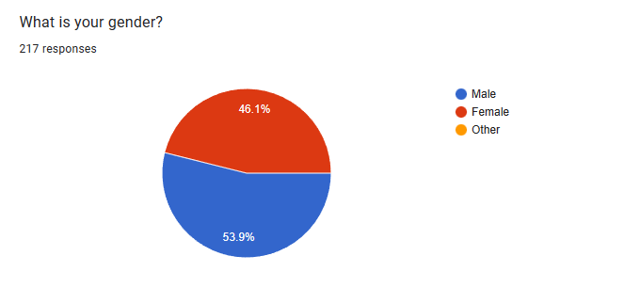

**Figure no: - 1.1**

|  |  |  |  |  |  |
| --- | --- | --- | --- | --- | --- |
| What is your gender? | | | | | |
|  | | Frequency | Percent | Valid Percent | Cumulative Percent |
| Valid | Male | 117 | 53.9 | 53.9 | 53.9 |
| Female | 100 | 46.1 | 46.1 | 100.0 |
| Total | 217 | 100.0  **Table no: - 1.1** | 100.0 |  |

**Interpretation: -** Above chart shows the ratio in percentage of male and female, which are 53.9% male and 46.1% female. In total there are 117 males and 100 females.

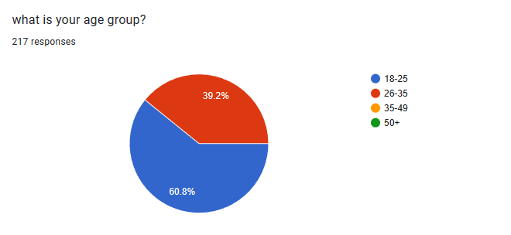

**Figure no: - 1.2**

|  |  |  |  |  |  |
| --- | --- | --- | --- | --- | --- |
| What is your age? | | | | | |
|  | | Frequency | Percent | Valid Percent | Cumulative Percent |
| Valid | 18-25 | 132 | 60.8 | 60.8 | 60.8 |
| 26-35 | 85 | 39.2 | 39.2 | 100.0 |
| Total | 217 | 100.0 | 100.0 |  |

**Table no: - 1.2**

**Interpretation: -** Above chart shows the age group of the various despondence, where 60.8% of people are below 25 and rest 39.2% are 26 or above. There are 132 peoples whose age is between 132 and 85 people whose age is between 26-35.

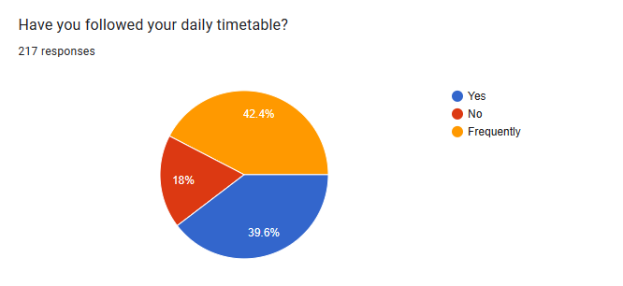

**Figure no: - 1.3**

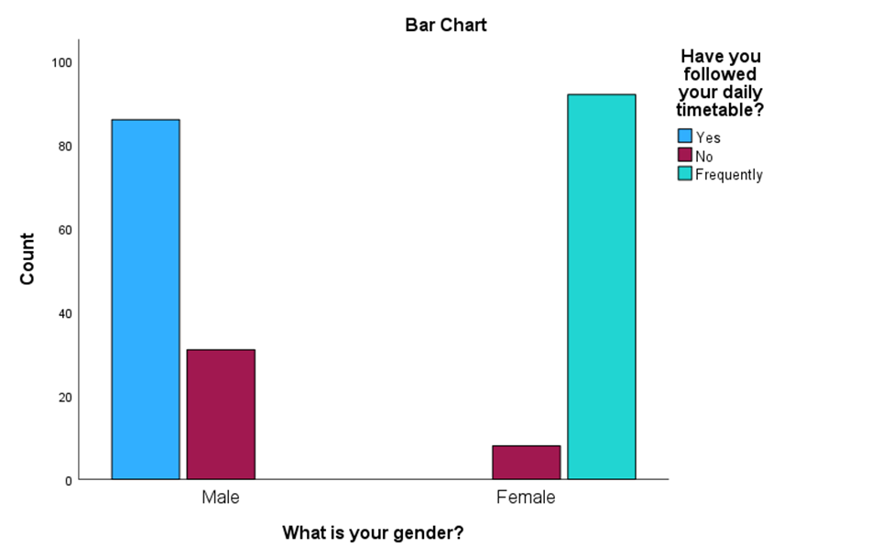

**Figure no: - 1.3.1**

**Interpretation: -** From the above table, it can be noticed that maximum 42.4% of people frequently follows their daily routine,39.6% of people do follows routine in daily bases and remaining 18% of people do not follows their daily routine.

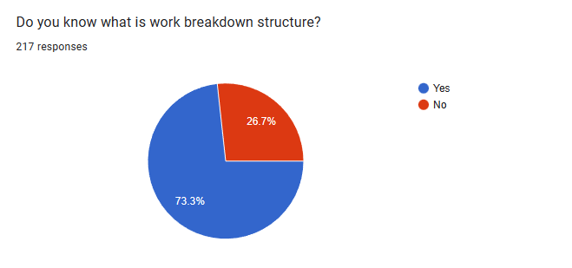

**Figure no: - 1.4**

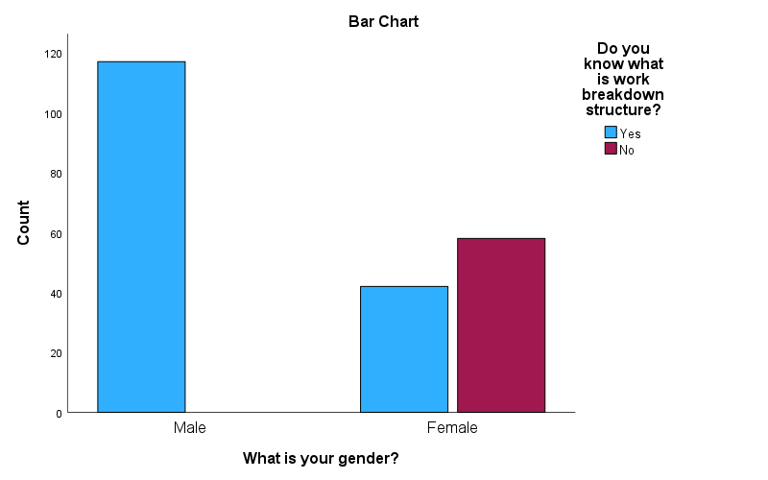

**Figure no: - 1.4.1**

**Interpretation: -** As per above chart 73.3% are aware of work breakdown structure are remaining 26.7% are not familiar. The following bar graph shows maximum number of male are aware about work breakdown structure and on the other side the nearly about 60 girls are aware and 40 girls are not aware about it.

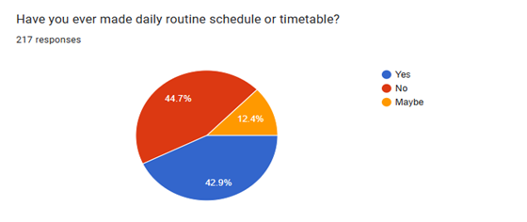

**Figure no: - 1.5**

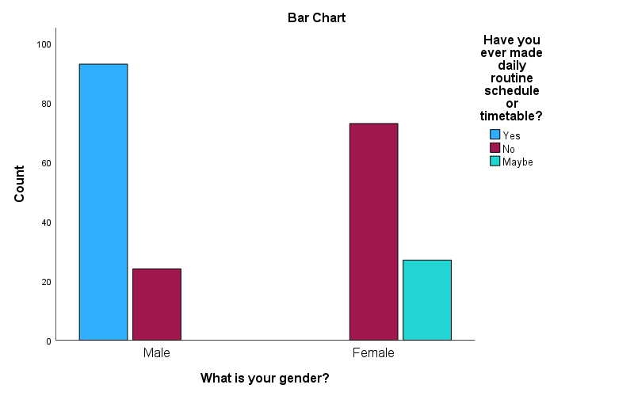

**Figure no: - 1.5.1**

**Interpretation: -** As per the above chart 42.9% follows daily routine which is good for daily basis work and 44.7% don’t make daily routine and other remaining 12.4% are not familiar with making timetable.

It is observed that male makes their daily routine schedule with compare to female.

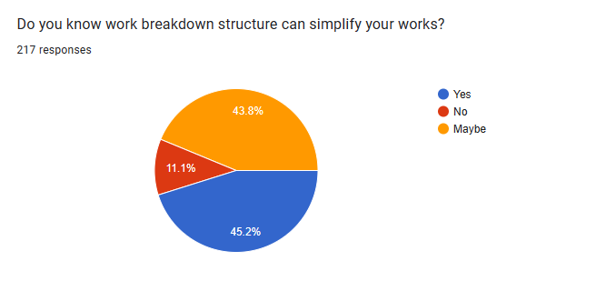

**Figure no: - 1.6**

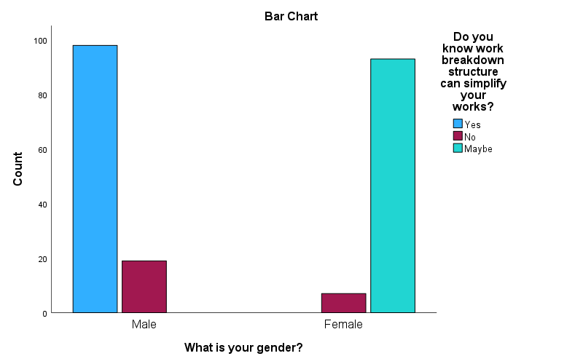

**Figure no: - 1.6.1**

**Interpretation: -** As per the data 45.2% are aware about work breakdown structure which can simplify work and knowns about it and rest remaining 11.1% are not familiar and 43.8% people are not familiar with work breakdown structure.

It is also observed that maximum number of male know about work breakdown structure than female.

**Figure no: - 1.7**

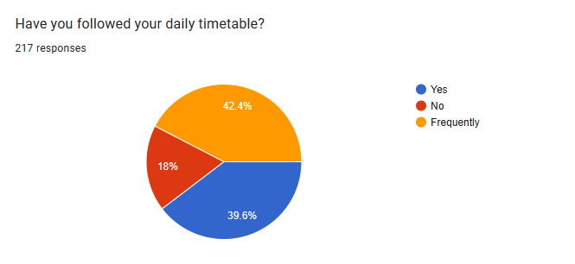

**Figure no: - 1.7.1**

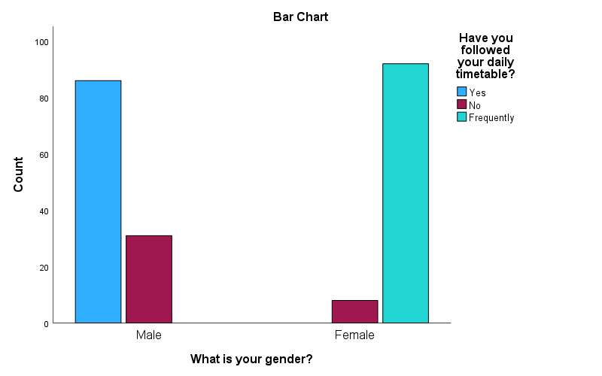

**Interpretation: -** 39.6% of people follows daily routine timetable and other 18% do not follow daily routine or do not follow it. It has been notice that maximum people which is 42.4% frequently makes their daily routine.

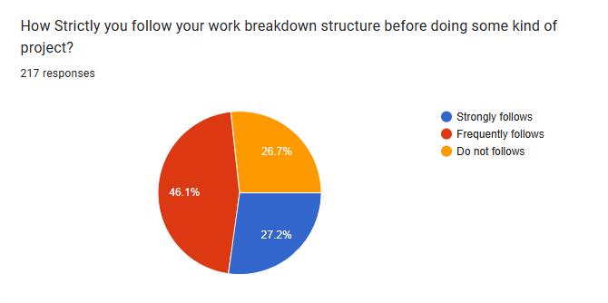

**Figure no: - 1.8**

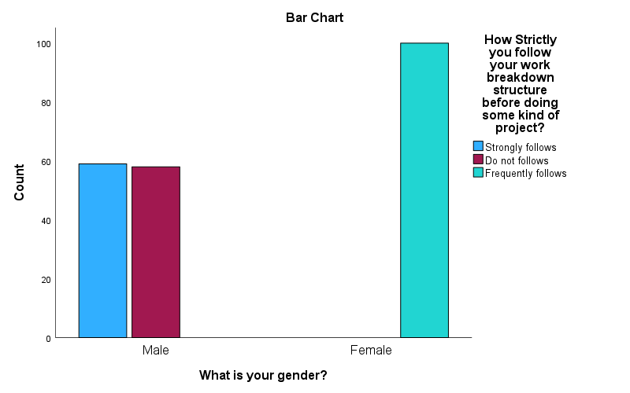

**Figure no: - 1.8.1**

**Interpretation: -** From the above data it can be notified that 80% of people knows how work breakdown structure works and rest 20% don’t know about it and it is also observed that maximum number of girls frequently follows work breakdown structure.

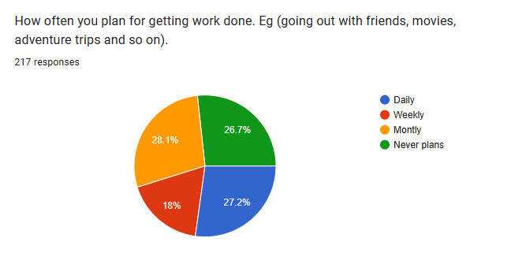

**Figure no: - 1.9**

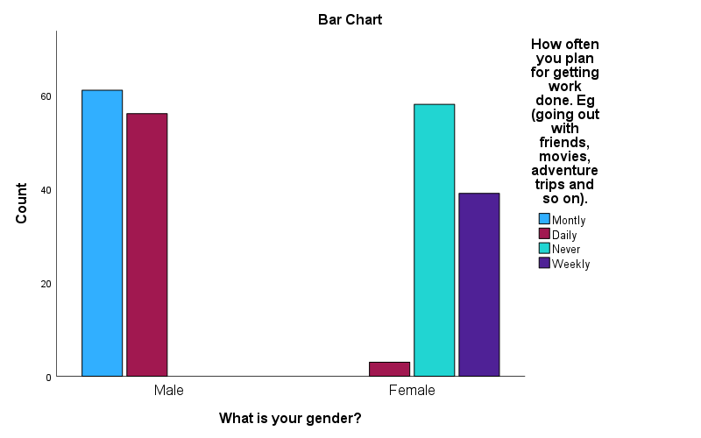

**Figure no: - 1.9.1**

**Interpretation: -** It has been noticed that maximum 28.1% of people are planning the things on the monthly basis before doing work done and it is very necessary to plan the things. Other 27.2% plans daily and work done and 18% plans on the weekly basis and remaining rest 26.7% never plan their work.

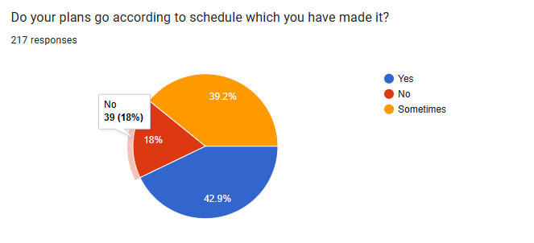

**Figure no: - 1.10**

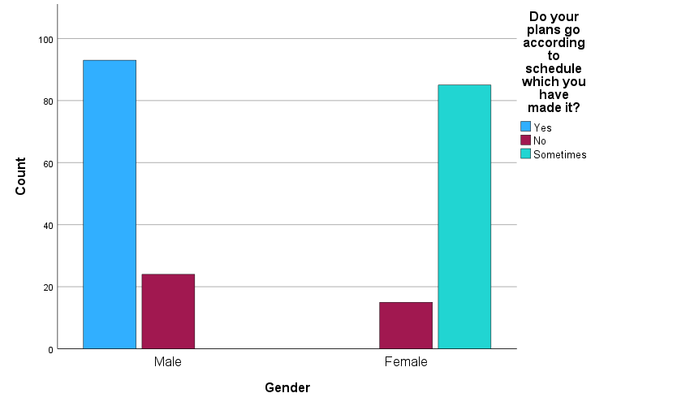

**Figure no: - 1.10.1**

**Interpretation: -** It has been observed that 42.9% of people plans goes according to schedule and for other 39.2% sometimes plans do goes according to plan and rest 18% of the people plans do not go according to them.

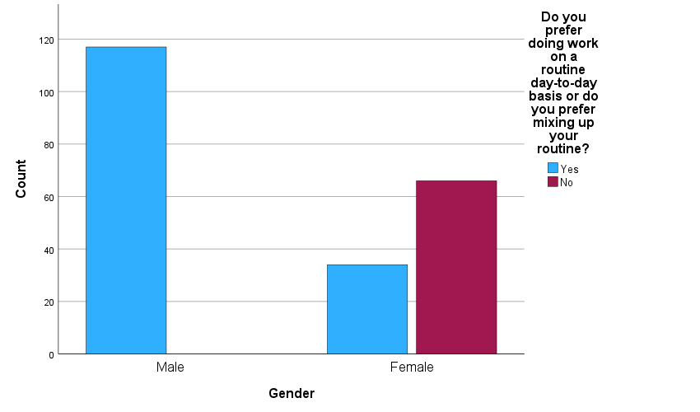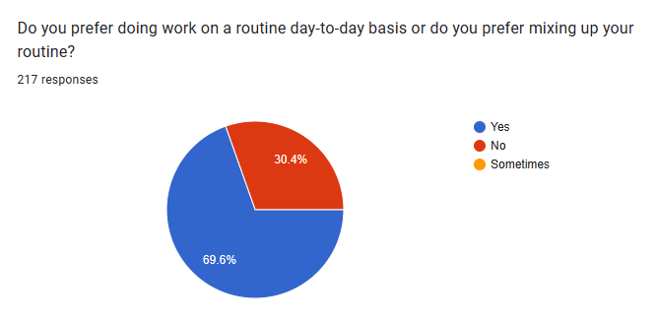

**Figure no: - 1.11.1**

**Figure no: - 1.11**

**Interpretation: -** It has been notice that maximum 69.6% people do their routine at daily bases and 30.4% of people prepare to mixing up routine.

|  |  |  |  |  |  |
| --- | --- | --- | --- | --- | --- |
| What is your gender? | | | | | |
|  | | Frequency | Percent | Valid Percent | Cumulative Percent |
| Valid | Male | 117 | 53.9 | 53.9 | 53.9 |
| Female | 100 | 46.1 | 46.1 | 100.0 |
| Total | 217 | 100.0 | 100.0 |  |

**Table no: - 1.3**

It has been observed that there are total 117 males and in percentage it is 53.9% and 100 females which make total of 217 numbers of people and in percentage it is 46.1%.

|  |  |  |  |  |  |
| --- | --- | --- | --- | --- | --- |
| What is your age? | | | | | |
|  | | Frequency | Percent | Valid Percent | Cumulative Percent |
| Valid | 18-25 | 132 | 60.8 | 60.8 | 60.8 |
| 26-35 | 85 | 39.2 | 39.2 | 100.0 |
| Total | 217 | 100.0  **Table no: - 1.4** | 100.0 |  |

It is observed that 132 peoples age is between 18-25 which about 60.8% years and rest 85 peoples age are between 26-35 years which is approximately 39.2%.

|  |  |  |
| --- | --- | --- |
| Reliability Statistics  **Table no: - 1.5** | | |
| Cronbach's Alpha | Cronbach's Alpha Based on Standardized Items | N of Items |
| .967 | .971 | 7 |

Reliability statistics provide valuable insights into the consistency and stability of a measurement or assessment tool. These statistics help evaluate the extent to which a test or instrument produces consistent and reliable results over time and across different conditions or raters. When interpreting reliability statistics, several key aspects should be considered. Cronbach's Alpha: A coefficient of 0.70 or higher is generally considered acceptable for most research purposes. Higher values indicate greater internal consistency reliability. Through the test it has been overserved that Cronbach alpha is 0.971 which very good for conducting research.

Following table shows the item statistic of research data.

|  |  |  |  |
| --- | --- | --- | --- |
| Item Statistics | | | |
|  | Mean | Std. Deviation | N |
| Do you know what is work breakdown structure? | 1.2673 | .44356 | 217 |
| Have you ever made daily routine schedule or timetable? | 1.6959 | .68016 | 217 |
| Do you know work breakdown structure can simplify your works? | 1.9770 | .94007 | 217 |
| Have you followed your daily timetable? | 2.0276 | .90736 | 217 |
| How Strictly you follow your work breakdown structure before doing some kind of project? | 2.1889 | .83681 | 217 |
| Do you know you can divide your work with the help of work breakdown structure so that there is minimum workload? | 2.1198 | .80762 | 217 |
| How often you plan for getting work done. Eg (going out with friends, movies, adventure trips and so on). | 2.3456 | 1.07384 | 217 |

**Table no: - 1.6**

**Chi Square Test**

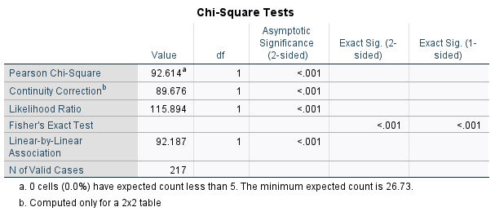

A chi-square test was conducted to examine the association between awareness of work breakdown structure (person who are aware vs. person who is not aware in males and female) and the development schedule in daily life(presence or absence of routine/timetable). The data was analyzed using a significance level of α = 0.05.

The results revealed a significant association between making daily time table and the development daily routine, χ²(1, N = 217) = 92.614, p < 0.001. The observed frequencies indicated that a higher proportion of people who knows work breakdown structure is (n = 159) makes daily routine compared to others (n = 58). The expected frequencies under the assumption of independence were 159 and 58 for making time table and not making time table, respectively. The chi-square test statistic exceeded the critical value, indicating a significant departure from the null hypothesis of independence.

**Table no: - 1.7**

Based on these findings, it can be concluded that making of daily schedule by male and female and the awareness of work breakdown structure are significantly associated.

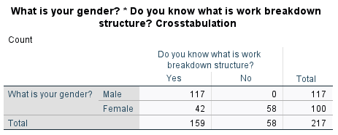

**Table no: - 1.8**

From the above data we can say that all the male is aware about work breakdown structure which is approximately 117 and 42 females are not aware about work breakdown structure as it is observed 58 females are aware about it. There is significant difference between male and female about awareness of work breakdown structure.

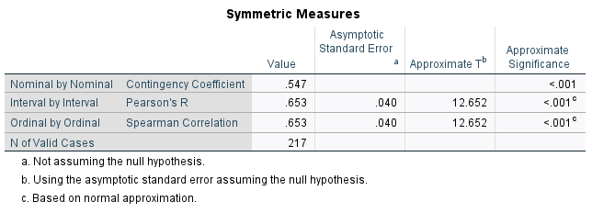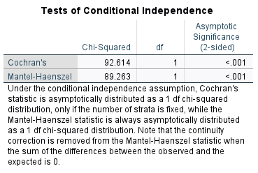

**Table no: - 1.10**

**Table no: - 1.9**

The test of conditional independence involves the formulation of a null hypothesis and an alternative hypothesis. The null hypothesis assumes that the two variables are conditionally independent given the third variable, while the alternative hypothesis suggests that there is a dependence between the variables even after considering the third variable.

|  |  |  |  |  |  |
| --- | --- | --- | --- | --- | --- |
| * Item-Total Statistics | | | | | |
|  | Scale Mean if Item Deleted | Scale Variance if Item Deleted | Corrected Item-Total Correlation | Squared Multiple Correlation | Cronbach's Alpha if Item Deleted |
| * Q1 | * 12.3548 | * 25.147 | * .698 | * .682 | * .977 |
| * Q2 | * 11.9263 | * 22.356 | * .875 | * .818 | * .963 |
| * Q3 | * 11.6452 | * 19.711 | * .941 | * .941 | * .957 |
| * Q4 | * 11.5945 | * 19.918 | * .952 | * .950 | * .956 |
| * Q5 | * 11.4332 | * 20.636 | * .936 | * .949 | * .957 |
| * Q6 | * 11.5023 | * 20.890 | * .936 | * .930 | * .958 |
| * Q7 | * 11.2765 | * 18.460 | * .958 | * .945 | * .958 |

**Table no: - 1.11**

Q1 Do you know what is work breakdown structure?

Q2 Have you ever made daily routine schedule or timetable?

Q3 Do you know work breakdown structure can simplify your works?

Q4 Have you followed your daily timetable?

Q5 How Strictly you follow your work breakdown structure before doing some kind of project?

Q6 How Strictly you follow your work breakdown structure before doing some kind of project?

Q7 Do you know you can divide your work with the help of work breakdown structure so that there is minimum workload?

Q8 How often you plan for getting work done?

**One sample T test**

Null Hypothesis (H₀): The mean perception score of individuals who are familiar with work breakdown structure (WBS) is equal to the population mean perception score.

Alternative Hypothesis (H₁): The mean perception score of individuals who are familiar with work breakdown structure (WBS) is significantly different from the population mean perception score.

In this hypothesis, we are comparing the perception scores of individuals who are familiar with work breakdown structure (WBS) with the population mean perception score. The null hypothesis states that there is no significant difference between the mean perception score of individuals who are familiar with WBS and the population mean perception score. The alternative hypothesis suggests that there is a significant difference between the mean perception score of individuals who are familiar with WBS and the population mean perception score.

**Table no: - 1.13**

|  |  |  |  |  |  |  |  |  |  |  |  |  |  |  |  |  |
| --- | --- | --- | --- | --- | --- | --- | --- | --- | --- | --- | --- | --- | --- | --- | --- | --- |
| **One-Sample Effect Sizes** | | | | | | | | | | | | | | | | |
|  | | | | | | Standardizera | | | Point Estimate | | | 95% Confidence Interval | | | | |
| Lower | | | Upper | |
| Gender | Cohen's d | | | | | .49962 | | | 2.924 | | | 2.617 | | | 3.229 | |
| Hedges' correction | | | | | .50136 | | | 2.914 | | | 2.608 | | | 3.218 | |
| Simplify | Cohen's d | | | | | .66932 | | | 2.479 | | | 2.209 | | | 2.747 | |
| Hedges' correction | | | | | .67165 | | | 2.470 | | | 2.201 | | | 2.737 | |
| a. The denominator used in estimating the effect sizes.  **Table no: - 1.12**  Cohen's d uses the sample standard deviation.  Hedges' correction uses the sample standard deviation, plus a correction factor. | | | | | | | | | | | | | | | | |
| One-Sample Test  The one-sample t-test was conducted to examine whether familiarity with work breakdown structure (WBS) has a significant impact on individuals' perception of its ability to simplify work. The following results were obtained:  The mean perception score of the sample familiar with WBS was found to be significantly higher than the population mean perception score (t = 43.072, df = 216, p < 0.05). This indicates that individuals who are familiar with WBS perceive it to be effective in simplifying their work. | | | | | | | | | | | | | | | | |
|  | |  | | | | | | | | | | | | | | | |
| t | df | | Significance | | | | | | Mean Difference | | | 95% Confidence Interval of the Difference | | | |
| One-Sided p | | | Two-Sided p | | | Lower | | Upper | |
| Gender | | 43.072 | 216 | | <.001 | | | <.001 | | | 1.46083 | | | 1.3940 | | 1.5277 | |
| Simplify | | 36.512 | 216 | | <.001 | | | <.001 | | | 1.65899 | | | 1.5694 | | 1.7485 | |
| **One-Sample Statistics** | | | | | | | | | | | | |
|  | N | | | Mean | | | Std. Deviation | | | Std. Error Mean | | |
| Gender | 217 | | | 1.4608 | | | .49962 | | | .03392 | | |
| Simplify | 217 | | | 1.6590 | | | .66932 | | | .04544 | | |

**Table no: - 1.14**

The effect size was measured using Cohen's d, which yielded a value of 0.499. This suggests a moderate effect, indicating a meaningful difference between the perception scores of individuals familiar with WBS and the population.

However, it is important to note that this study focused solely on individuals' perceptions, and further research is recommended to investigate the actual impact of WBS on work simplification and to consider other factors that may influence this relationship.